Name = Krish
Roll Number = 241010177
- Add Customer , Car , Rentals Details and Press add
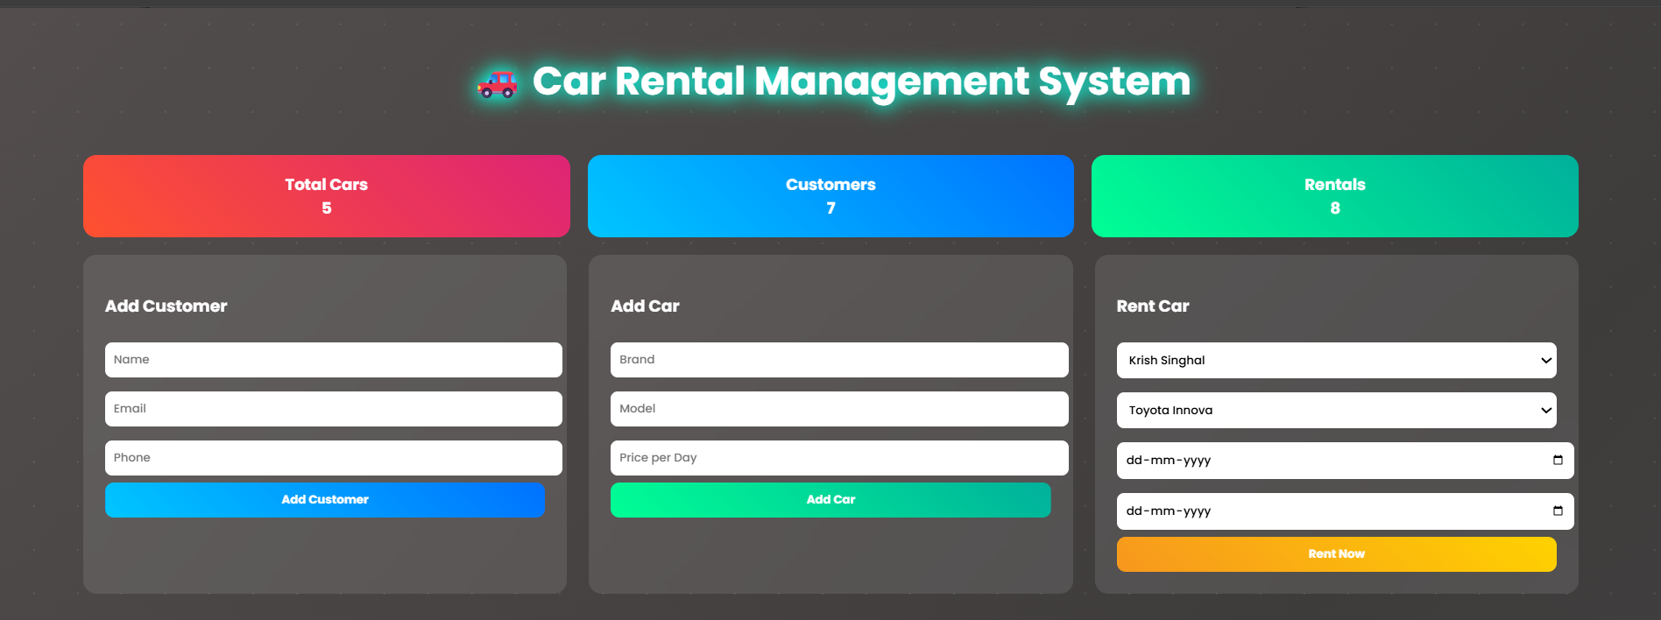
- Customer, Car and rentals Details Add
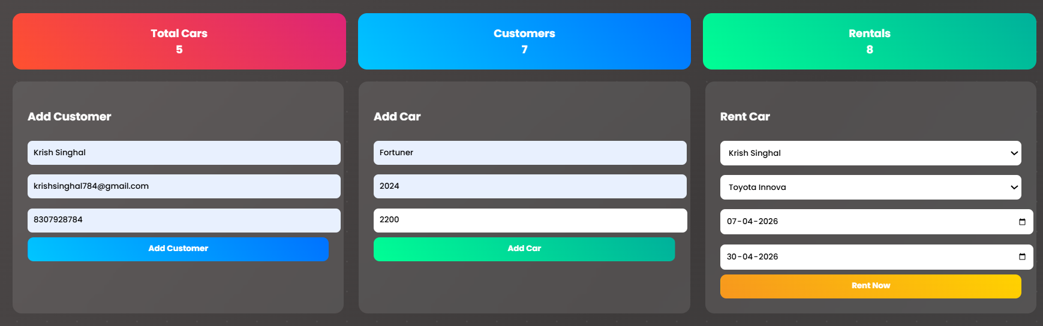
- Details of all customer who can take car as rent
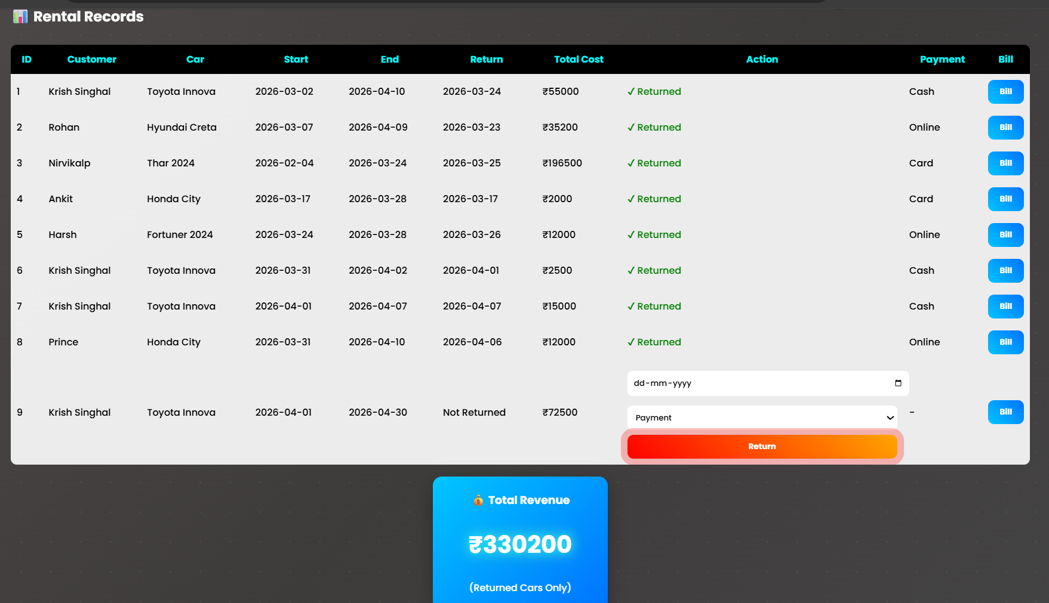

- After adding rental return car Return date and payment mode the revenue added in the total revenue.

